**TASK-5**

**Create Azure Scale Set, Recovery and backup of VM and Encryption of VM disk**

**Scale Set**

1. Create a resource group with name AnnuRG.

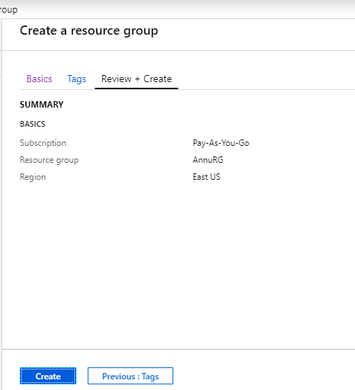

1. Created Scale Set with name **AnnuScaleSet** in AnnuRG Resource group.

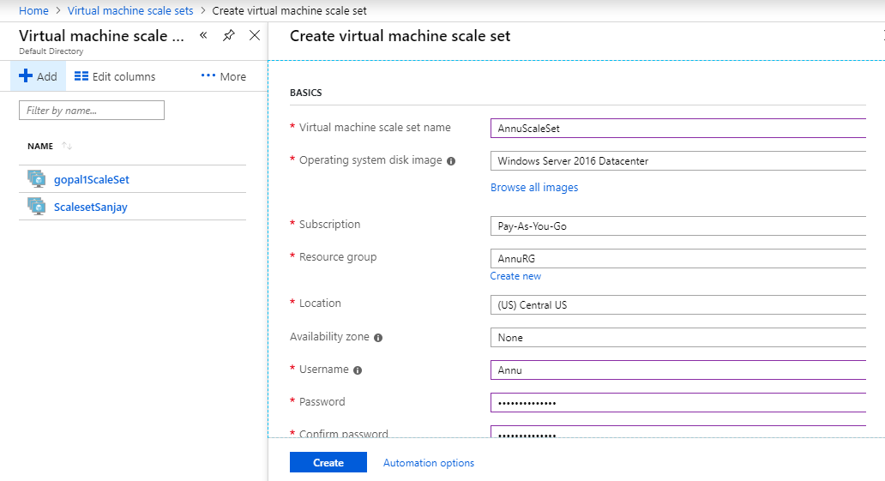

**Recovery and Backup of VM**

1. Created virtual machine with name **AnnuVM**

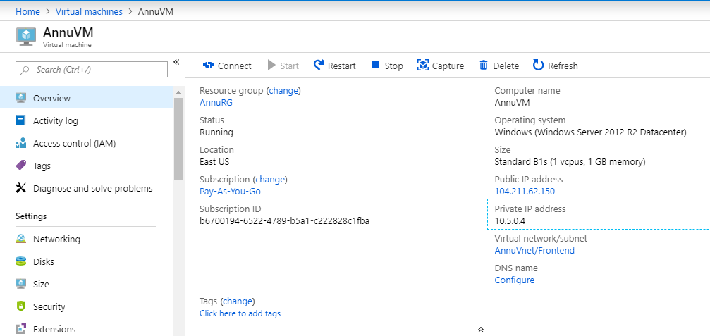

1. Created Recovery Services Vault with name **AnnuRSV**

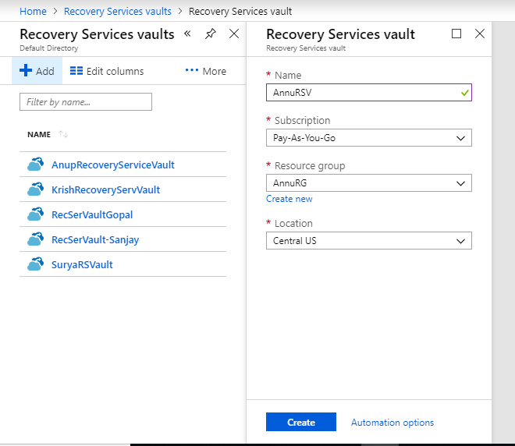

1. Created Backup of AnnuVM in AnnuRSV Recovery Service Vault and then **Enable backup**.

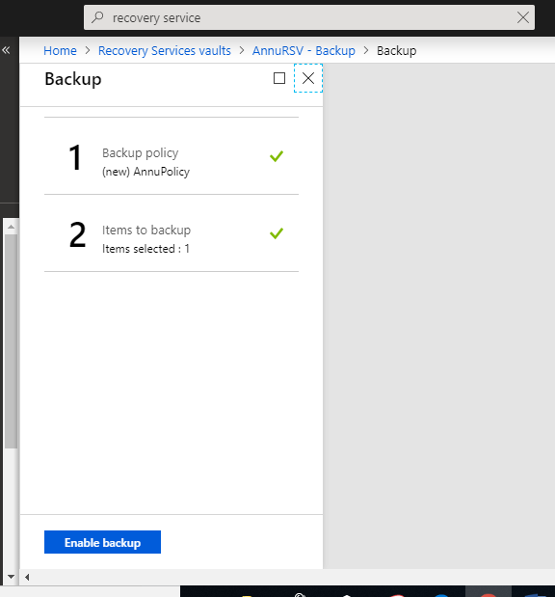

**Encryption of VM Disk**

1. In azure active directory created App registration.

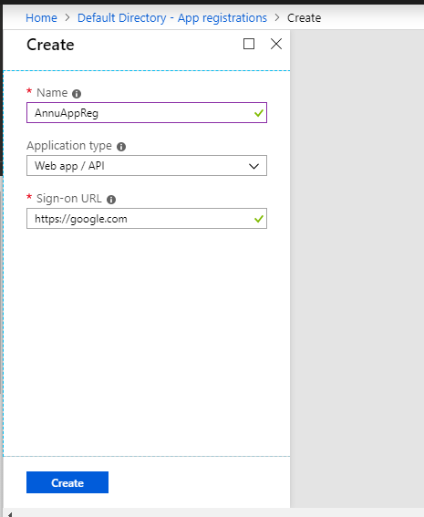

1. Created Key Vault with name AnnuKV, while creating key vault add access policy.

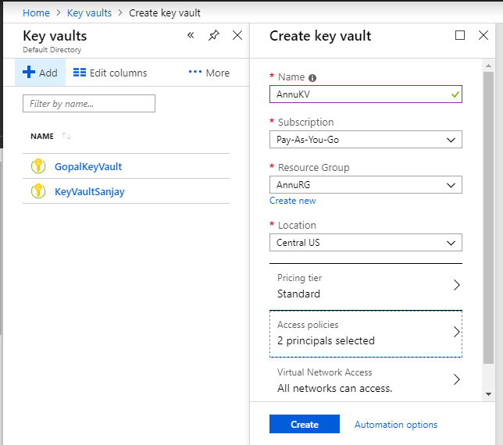

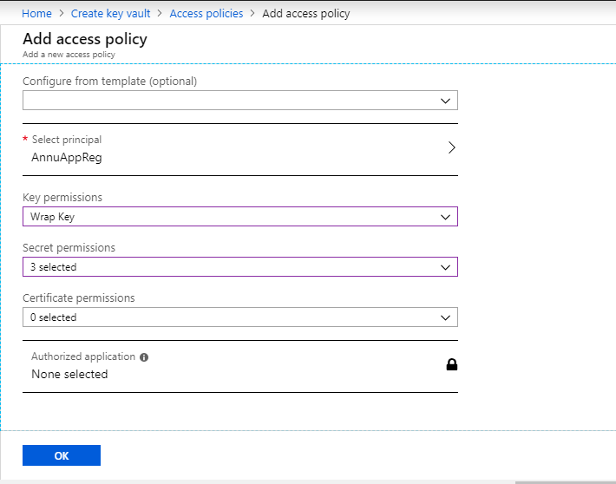

1. In AnnuAppReg App Registration go to Setting and create key and save it.

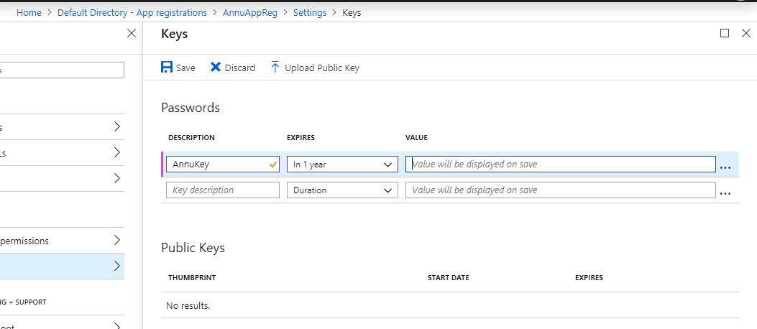

1. Copy the key value.

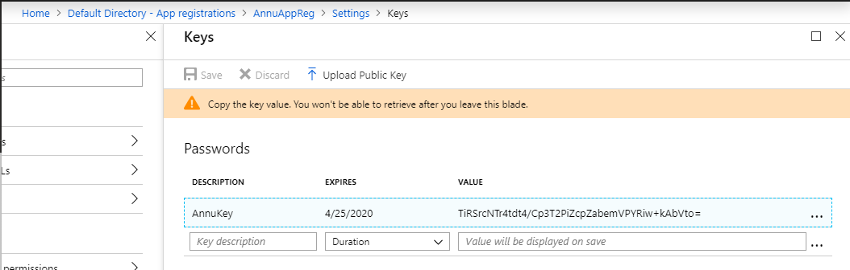

1. For encryption of VM, type 201-encrypt-running-windows-vm in google and fill the details and clicked on purchase.

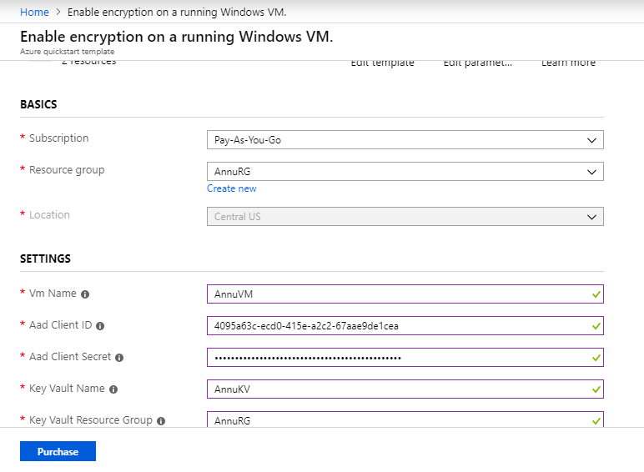

1. In Virtual machine, in disk we can see the OS disk encryption is Enabled.

